Learning Stations
SVT (Supraventricular Tachycardia) Fast, Regular, Narrow
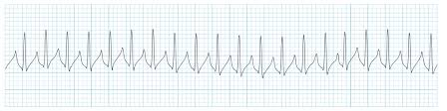
Stable:
* Vagal Maneuvers
* Adenosine 6mg
* Adenosine 12mg
Unstable:
Cardioversion 50J, 100J, 150J, 200J

V-TACH WITH A PULSE (Ventricular Tachycardia) Fast, Regular, Wide
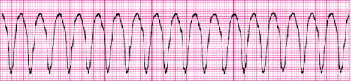
Stable:
Call for consult*
Unstable:
Cardioversion 50J, 100J, 150J, 200J

Torsade De Pointes (Irregular V-Tac) Fast, Irregular, Wide
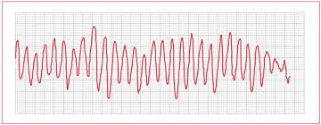
* Magnesium Sulphate - 1-2 Grams
* Unsynchronized Cardioversion (Defibrillation)

V-Fib (Ventricular Fibrillation) or pVT (Pulseless V-Tach) are NOT organized rhythms
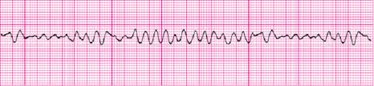
- Check it
- Shock it
- CPR it
- Drug it
* Defibrillate 200J
* CPR
* EPI 1 mg
*********************************** 2 minutes
* Defibrillate 200J
* CPR
* Amiodarone 300 mg
********************************** 2 minutes
* Defibrillate 200J
* CPR
* EPI 1 mg
********************************* 2 minutes
* Defibrillate 200J
* CPR
* Amiodarone 150 mg
******************************** 2 minutes
* High Quality CPR
* EPI every 4 minutes
* Consider Intubation
* ROSC? Consider Hypothermia (32-36 C for at least 24 hours)

Asystole PEA (Push Epi Always)
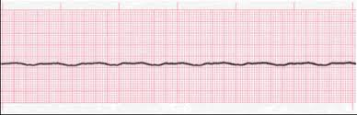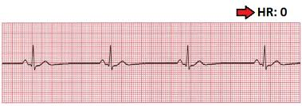
Treatments:
- Check it
- CPR it
- Drug it (EPI only)
* High quality CPR
* EPI every 4 minutes
* NO Amiodarone
* Non-shockable!!!

Bradycardias (Less than 50 BPM)
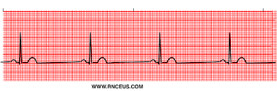
Stable: Monitor/Observe
Unstable: Atropine 1.0 mg (3 mg max) NOT for 3rd degree HB
* Dopamine Infusion 5-20 mcg/kg/min
* Epinephrine 2-10 mcg/min
* Pacing
*Treatment sequence based on symptoms

Heart Block Recognition Tips

First Degree (If your R’s are far from P’s, you probably have a First Degree)

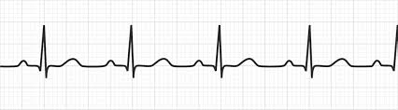

Second Degree Type 1, Mobitz 1, Wenckebach (Long, long, longer drop- must be a Wenckebach)
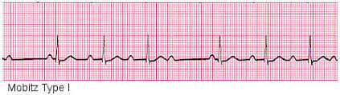

Second Degree Type 2, Mobitz 2 (If you see a P that doesn’t have a Q, you probably have a Mobitz 2)
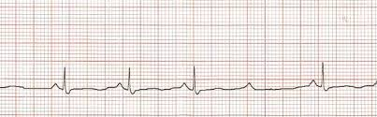

Third Degree Heart Block (If your P’s and Q’s do not agree, you probably have a 3rd degree)
